**PROJECT REPORT**

# ON

# ANDROID CHAT APPLICATION

# (VCHAT)



**SUBMITTED TO**

**UNIVERSITY OF MUMBAI**

**IN PARTIAL FULFILLMENT OF REQUIREMENT OF**

**MASTER IN COMPUTER APPLICATION**

**SUBMITTED BY:**

**MUKESH VERMA**

**AKSHAY MISTRY**

**UNDER THE GUIDANCE OF**

**PROF. MEERA GOHIL**

**PROF. RUPALI JADHAV**

**THAKUR INSTITUTE OF MANAGEMENT STUDIES, CAREER DEVELOPMENT & RESEARCH**

**MUMBAI**

**2018-2019**

**Certificate**

This is to certify that the project entitled ANDROID CHAT **APPLICATION** submitted by **MUKESH VERMA, AKSHAY MISTRY**, for partial fulfillment for the degree of Master in Computer Applications from University of Mumbai.

It is the software developed by him/ her and has undergone the requisite duration as prescribed by the **University of Mumbai** for Summer Project (Mini Project).

**Internal Guide Examiner**

# 

**ACKNOWLEDGEMENT**

In writing this project report, it has been our endeavor to present the subject in simple and lucid manner to those who wish to refer it for enhancement or improving the existing features. The knowledge that we have gathered, study of relevant literature for understanding our project, planning of details and suitable software platform by itself and acknowledgement to the industry zeal and technical competence of those many individuals who have contributed to it with profound gratitude, We wish to acknowledge them.

We sincerely thank Thakur Institute of Management Studies, Career Development & Research for training us in the MCA course. We express our deep gratitude to our honorable director **Dr. Vinita Gaikwad** and we would also express our deep gratitude to our internal guides **Ms. Meera Gohi**l & **Ms. Rupali Jadhav** Their expertise and insight was invaluable to us during our internship period.

**Index**

|  |  |  |
| --- | --- | --- |
| **Sr. No.** | **Content** | |
| **1** | **Introduction** |  |
|  |  | 1.1 Introduction of the Project |
|  |  | 1.2 Problem definition |
|  |  | 1.3 Objective of Project |
|  |  | 1.4 Scope of Project |
| **2** | **Literature Survey** |  |
|  |  | 2.1 Existing System |
|  |  | 2.2 Proposed System |
| **3** | **Analysis** |  |
|  |  | 3.1 Feasibility Analysis |
|  |  | 3.2 DFD |
| **4** | **Methodology** |  |
|  |  | 4.1 Criteria & Constraints |
|  |  | 4.2 Tools used |
|  |  | 4.3 Procedure |
| **5** | **Design & Developing a Prototype** |  |
|  |  | 5.1 Module design & Organization |
| **6** | **Testing & Validation** |  |
|  |  | **7.1 Test Cases and Report** |
| **7** | **User Manual** |  |
|  |  | 8.1 Output Screens |
| **8** | **Conclusion** |  |
|  |  | Project Conclusion & Future enhancement |

1. **Introduction**

**1.1 Introduction of the Project**

Communication is a mean for people to exchange messages. It has started since the beginning of human creation. Distant communication began as early as 1800 century with the introduction of television, telegraph and then telephony. Interestingly enough, telephone communication stands out as the fastest growing technology, from line to mobile wireless, from voice call to data transfer. The emergence of computer network and telecommunication technologies bears the same objective that is to allow people to communicate.

All this while, much efforts has been drawn towards consolidating the device into one and therefore indiscriminate the services. Chatting is a method of using technology to bring people and ideas together despite of the geographical barriers. The technology has been available for years but the acceptance it was quit recent. Our project is an example of a chat server. It is made up of applications the client application which runs on the users mobile and server application which runs on any pc on the network. To start chatting our

Client should get connected to server where they can do Group and private chatting.

Teleconferencing or Chatting, is a method of using technology to bring people and ideas “together” despite of the geographical barriers. The technology has been available for years but the acceptance it was quit recent. Our project is an example of a chat server. It is made up of 2 applications the client application, which runs on the user’s Pc and server application, which runs on any Pc on the network. To start chatting client should get connected to server where they can practice two kinds of chatting, public one (message is broadcasted to all connected users) and private one (between any 2 users only) and during the last one security measures were taken.

One of the learning outcomes listed by ACM mobile computing education is to “Implement a simple application that relies on mobile and wireless data communications”.

Smartphone devices such as iPhone, Blackberry, and those that support the Android operating system are ubiquitous. In addition to serving as a phone device, smartphones are also capable of video/picture/text exchanges, accessing the Internet and executing sophisticated embedded software applications. A large percentage of these users are young adults that include college students. Hence, the interest on engaging in the development of the next generation of software applications for embedded and mobiles devices is arising among students.

Since the Android mobile platform was first open sourced by Google in November 2007, it has attracted more than 180,000 developers and the deployment of 50,000 mobile applications in the Android Market. Today more than 60 smart phones from major manufactures run the Android platform. All these numbers show the Android project has gained momentum and has moved forward.

We believe Android provides a rich platform with a variety of concepts, techniques, and resources which can be combined to produce useful and marketable applications. In addition to its openness, all the tools in the Android development are free and no special hardware is required. These factors motivated us to practice an instant message application on the Android platform to explore Android’s main components and various building blocks, and to acquire a working knowledge of its developing environment.

The Android operating system is developed by the Open Handset Alliance led by Google. It includes a large set of features for supporting mobile applications. Android consists of a kernel based on the Linux kernel, with middleware, libraries and APIs written in C and application software running on an Application Framework which includes Java compatible libraries based on Apache Harmony. Android uses the virtual machine with just-in-time compilation to run compiled Java code. The Android development environment includes a device emulator, tools for debugging, memory and performance profiling, and a plugin for the Eclipse IDE. The programming language is Java.

The emulator available in the Android SDK is a tool that allows developers to easily test applications without having to install it to a real device. With the proper configuration for an emulator, it is also possible to test situations which are hard to reproduce on a physical device.

* 1. **Problem Definition**

This project is to create a chat application with a server and users to enable the users to chat with each other.

To develop an instant messaging solution to enable users to seamlessly communicate with each other.

The project should be very easy to use enabling even a novice person to use it.

* 1. **Objective of Project**

It provide the user friendly environment where user can get better chat Service.

It keeps a track of users added in the database. It also make functioning of Chat Faster

1.3 **Scope of Project**

This document provides a scalable scheduling tool and associated schedule development, analysis, and monitoring methods that can be used by Implementing Agencies (IA) to prepare, monitor, and report project schedules. Our Project is not that complex so we will not use very complex scheduling method.

1. **Literature Survey**

**2.1 Existing System:**

When the existing system was studied, it was found having some problems, existing system was very time consuming and was not very efficient. The drawback of the existing system has resulted in to the development of new system, which is very user friendly and effective. Existing system was also very low in performance.

While developing the new system all requirements of the end user was taken into consideration. These have been maximum efforts towards overcoming the drawbacks of the existing system, while the new system was designed & developed.

**2.2 Proposed System:**

The system to be developed here is a Chat facility.

* It is a centralized system.
* It is Client-Server system with centralized database server.
* All local clients are connected to the centralized server via LAN.
* There is a two way communication between different clients and server.
* This chat application can be used for group discussion.
* It allows users to find other logged in users.

1. **Analysis**
   1. **Feasibility Analysis**

* **Technical Feasibility:**

The current system developed is technically feasible. It provides an easy access to users. It provides technical guarantee of accuracy, reliability and security. As the administrator is well versed in using a computer, so no extra knowledge needs to be imparted. Since, the administrator already has a PC with the necessary system requirements; it does not require any additional hardware or software.

* **Economic Feasibility:**

The system is economically feasible. Since, the administrator already has a PC with the necessary system requirements; it does not require any additional hardware or software. So, no extra costs are needed to be incurred. The anticipated values of benefits will be definitely greater than project cost of development. The economic feasibility also deals with whether the organization has enough economic support since this system will be developed in less amount of time. The overall amount cost will be very low.

* 1. **Diagrams**
* **Data Flow Diagram**

Login

Chat Dashboard

Chat

Sign Out

1. **Methodology**

**4.1 Criteria and Constraint:**

1. Index -

The Dashboard of chat of the System.

1. Login -

Here the user will do the required login to enter the chat and enter the chat Dashboard.

1. Notifications-

Will see the notifications added to the respective chat

1. Sign Out-

This module help to sign Out of the module.

* 1. **Tools used:**
* Project Deliverable's:

1. An android app

2. Documentation

3. Readme File

* Hardware Interface

1. Android Phone

2. 128 MB minimum RAM Required

3. Internet or LAN Connections

4. Processor with Speed of 500 MHz

* 1. **Procedure:**

The user interacts with the tool using GUI. The GUI Operates in two

Form, Contacts Forms and Chat forms. The contacts forms contains list

Of all friend and the Chat form will be used to chat with friends.

**5. Design and developing a prototype:**

1. **Model:  
   Waterfall Model:**

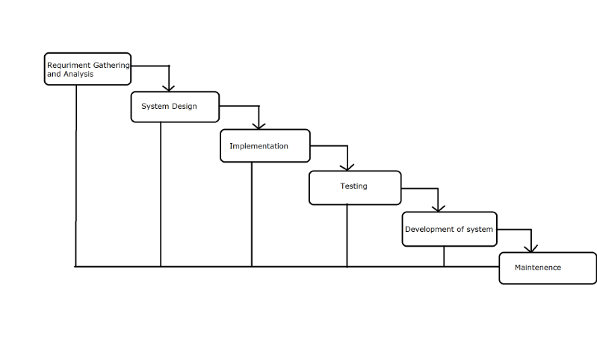

The sequential phases in the Waterfall Model are:

* **Requirement Gathering and Analysis:**

All possible requirements of the system to be developed are captured in this phase and documented in a requirement specification doc.

* **System Design:**

The requirement specifications from first phase are studied in this phase and system design is prepared. System Design helps in the specifying hardware and system requirements and also helps in defining overall system architecture.

* **Implementation:**   
  With inputs from system design, the system is first developed in small programs called units, which are integrated in the next phase. Each unit is developed and tested for its functionality which is referred to as Unit Testing.
* **Integration and Testing:**

All the units developed in the implementation phase are integrated into a system after testing in of each unit. Post integration the entire system tested for any faults and failure.

* **Deployment of system:**

Once the functional and non-functional testing is done, the product is deployed in the customer environment or released into the market.

* **Maintenance:**   
  There are some issues which come up in the client environment. To fix those issues patches are released. Also to enhance the product some better versions are released. Maintenance is done to deliver these changes in the customer environment. All these phases are cascaded to each other in which progress in seen as flowing steadily downwards (like a waterfall) through the phases. The next phase is started only after the defined set of goals are achieved for previous phases and it is signed off, so the name “Waterfall Model”. In this model phases do not overlap.

* **Waterfall Model Application:**

Every software developed is different and requires a suitable SDLC approach to be followed based on the internal and external factors. Some situations where the use of Waterfall model is most appropriate are: Requirements are very well documented, clear and fixed. Product definition is stable. Technology is understood and is not dynamic. There are no ambiguous requirements. Ample resources with required expertise are available to support the product. The project is short.

* **ADVANTAGES:**
* The advantage of waterfall development is that it allows for departmentalization and control.
* A schedule can be set with deadlines for each stage of development and a product can proceed through the development process model phase one by one.
* Development moves from concept, through design, implementation, testing, installation, troubleshooting, and ends up at operation and maintenance.
* Each phase of development proceeds in strict order.

* **DISADVANTAGES:**
* The disadvantage of waterfall development is that it does not allow for much reflection or revision.
* Once an application is in the testing stage, it is very difficult to go back and change something that was not well-document or through upon in the concept stage.

**6. Testing & Validation:**

**System Testing:**

Software testing is a critical element of software quality assurance and represents the ultimate review of specification, design and coding. In fact, testing is the one step in the software engineering process that could be viewed as destructive rather than constructive.

A strategy for software testing integrates software test case design methods into a well-planned series of steps that result in the successful construction of software. Testing is the set of activities that can be planned in advance and conducted systematically. The underlying motivation of program testing is to affirm software quality with methods that can economically and effectively apply to both strategic to both large and small-scale systems.

**Unit Testing:**

Unit testing focuses verification effort on the smallest unit of software design, the module. The unit testing we have is white box oriented and some modules the steps are conducted in parallel.

**White Box Testing:**

This type of testing ensures that

* All independent paths have been exercised at least once.
* Logical decisions have exercised on their true false sides.
* All loops are executed at their boundaries and within their operational bounds.
* All internal data structures have exercised to assure their validity.

**7. User Manual:**

**8.1 Output Screens:**

**1. First Screen 2. Login Screen**

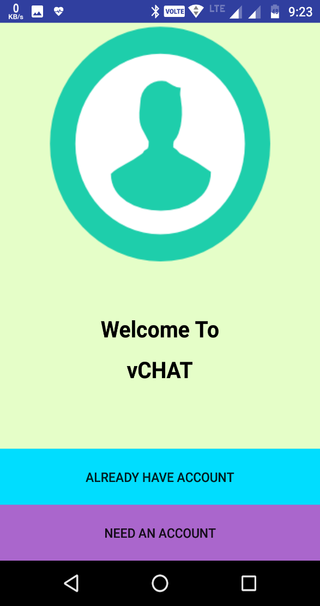 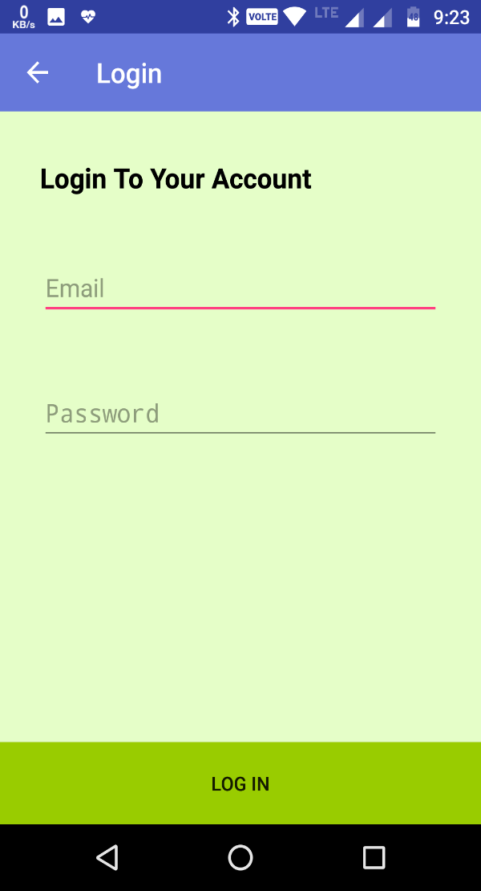

**3. Create account 4. All users**

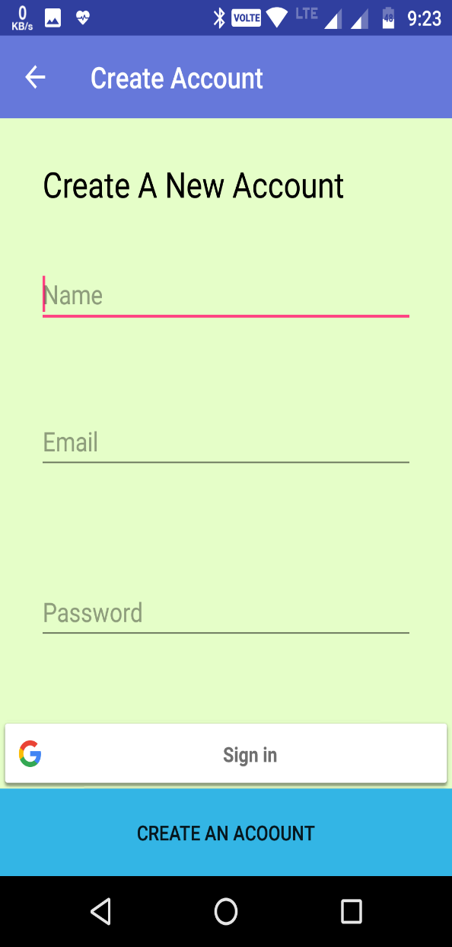 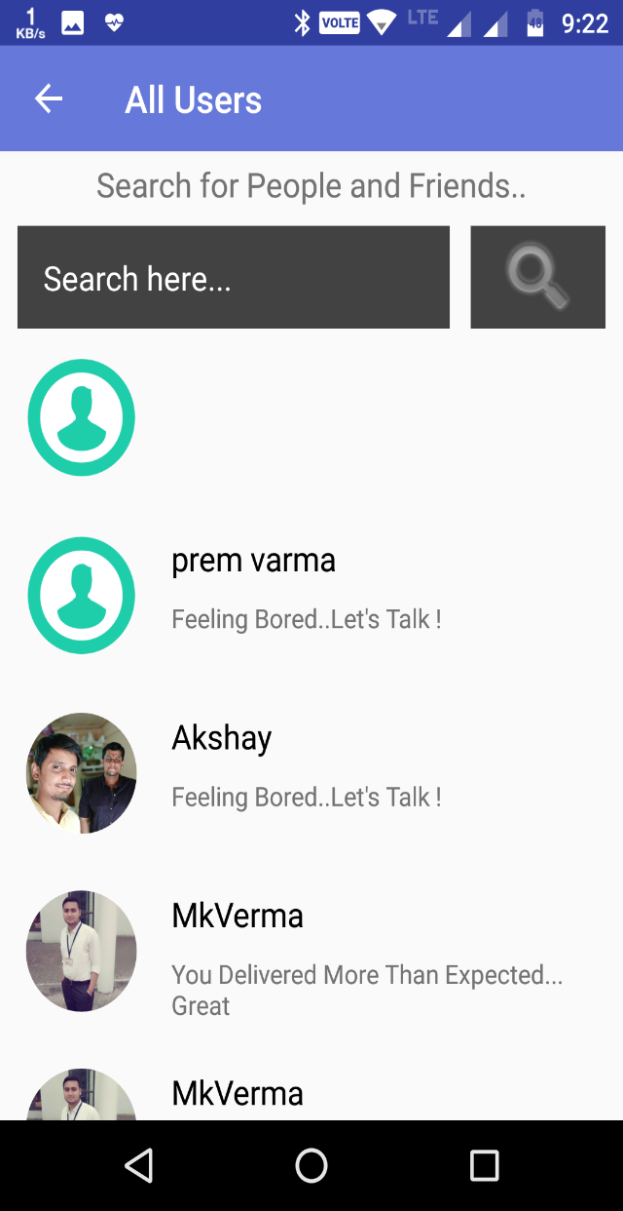

**5. Chat Page 6. Request Page**

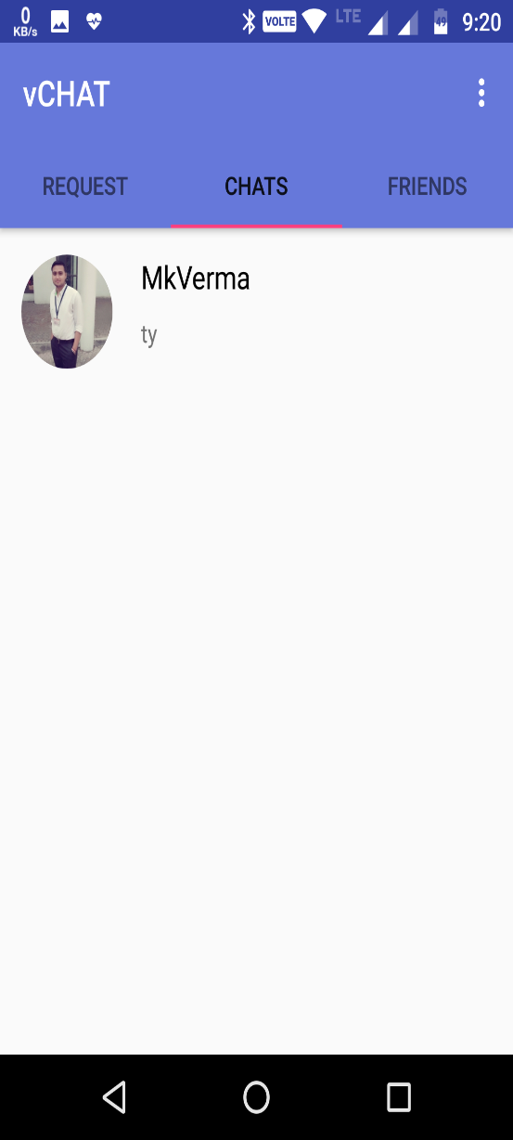 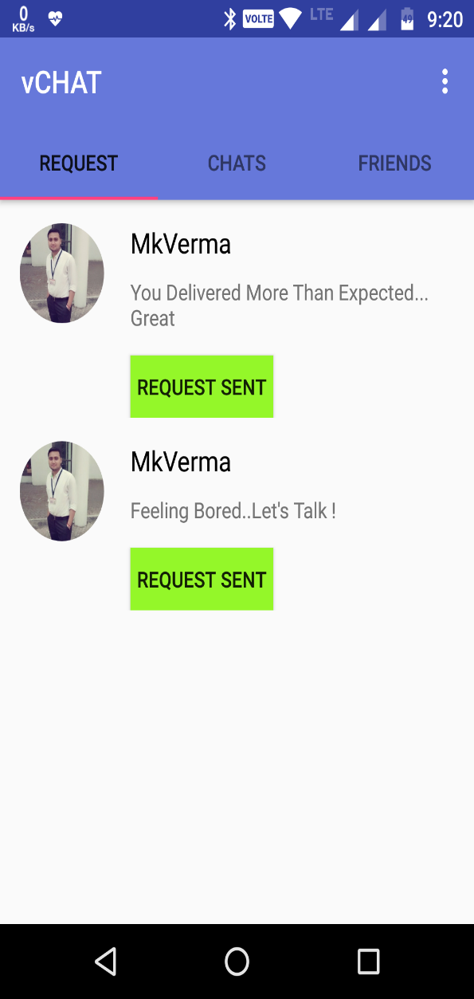

**7. Friend Page 8. Chat**

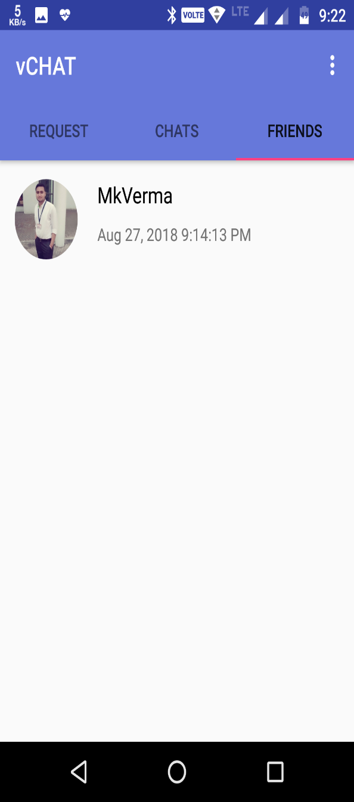 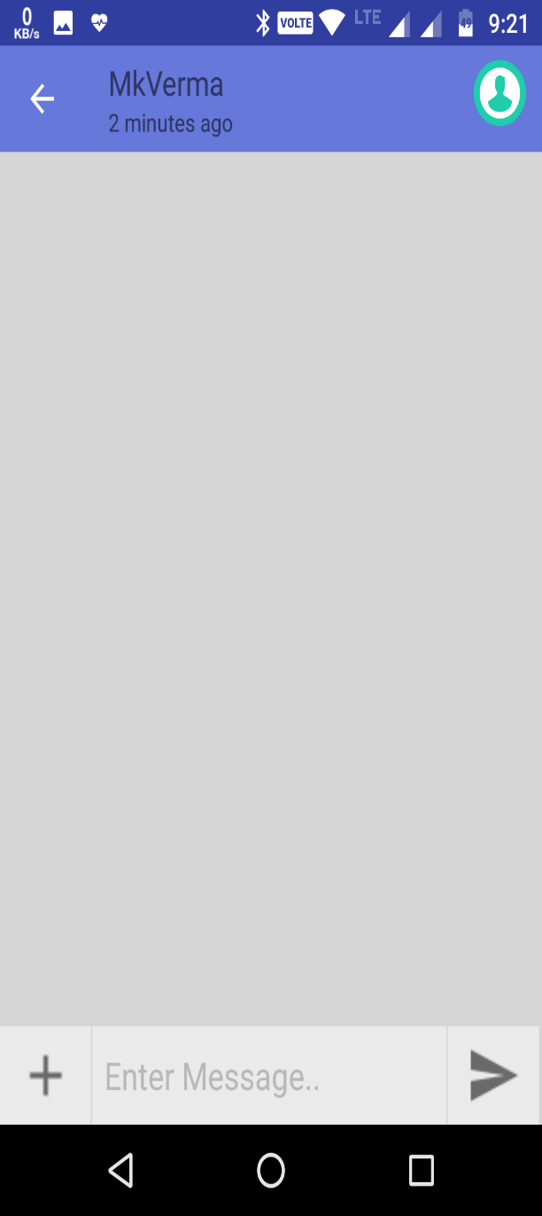

**9. Setting Page 10. Media File Share**

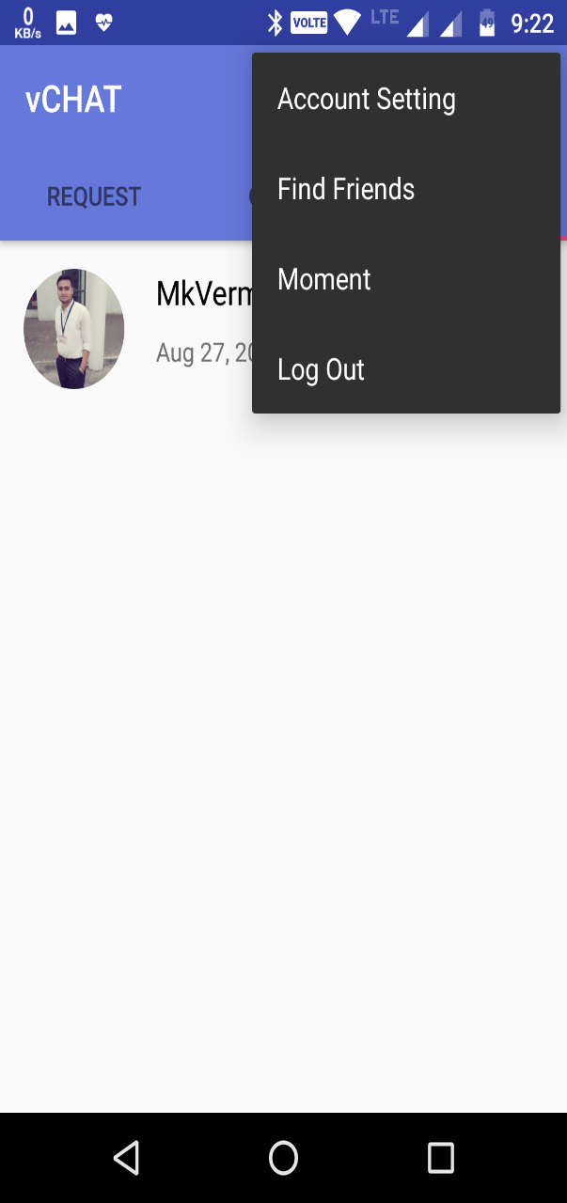 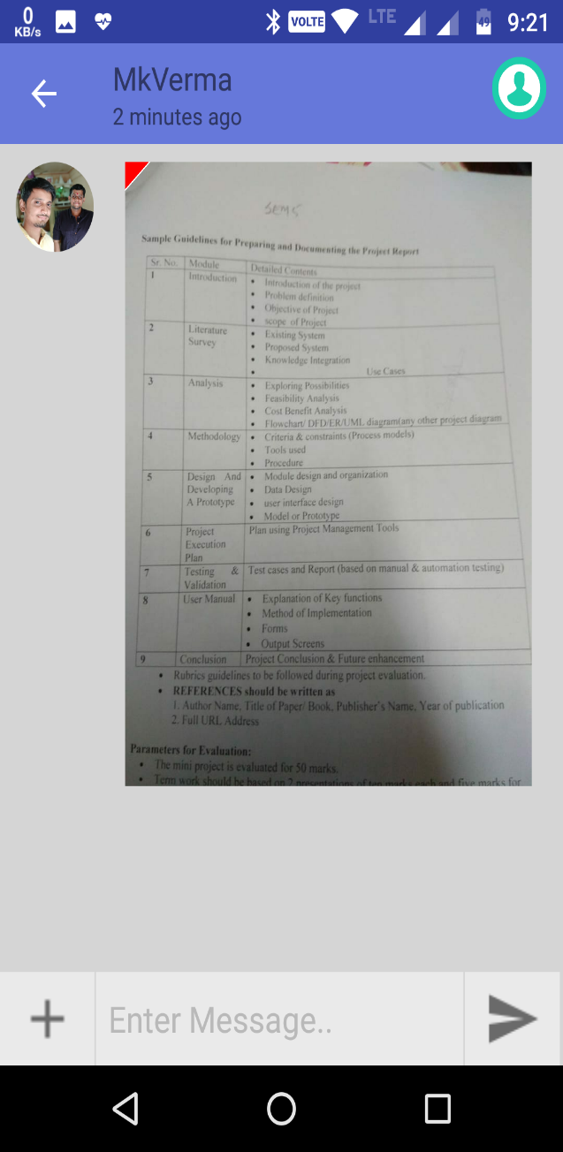

**11. Change Status 12. Change Profile Picture**

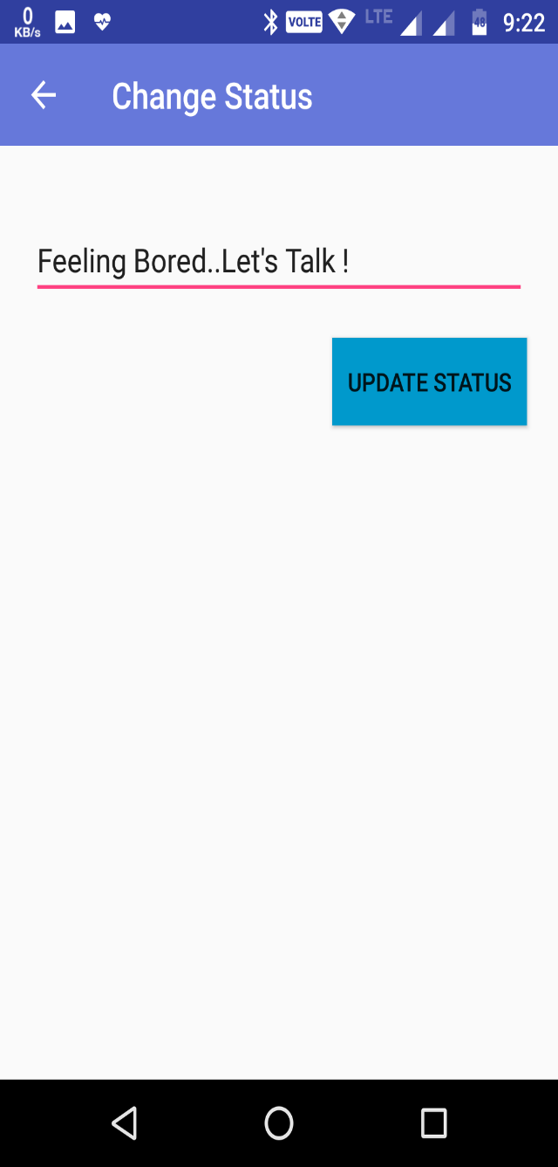 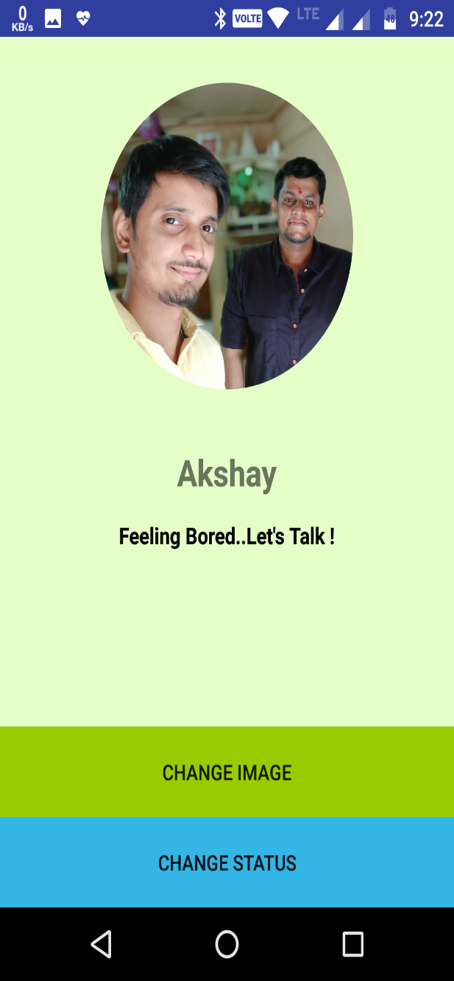

**8. Conclusion:**

There is always a room for improvements in any apps. Right now we are just dealing with text communication. There are several android apps which serve similar purpose as this project, but these apps were rather difficult to use and provide confusing interfaces. A positive impression is essential in human relationship as well as in human computer interaction. This project hopes to develop a chat service Android app with high quality user interface.

In future we may be extended to include features such as:

1. File Transfer

2. Voice Message

3. Video Message

4. Audio Call

5. Video Call

6. Group Call

**Future Enhancements-**

1. Will add the latest feature available for the user to have a better chat Experience
2. Include the privacy and setting for user profile managements
3. Update the module App with the new Release of the Version of vChat.
4. Include the flash Screen in the Application Module.

**9. Bibliography**

**Websites:-**

* **http://stackoverflow.com**
* **www.coverfox.com**
* **www.tutorialspoint.com**